Table of Contents:

Table of Figures and Table

Abstract

This project is focused on showing machine learning applications on IMDB Movie Rating dataset with multiple genres where regression, classification and clustering methods are applied to extract meaningful insights. The analysis has four phases: feature engineering and exploratory data analysis, regression analysis, classification analysis, and clustering with association rule mining.   
In Phase I: Following a rigorous treatment of the missing value and duplicate values, handle unwanted values, detection of outliers, and application of dimensional reduction to ensure strength in the dataset, the model went for serious data pre-processing. Feature transformations, like normalization and encoding, were done to help the model perform optimally.  
Phase II: Multiple linear regression to predict a continuous variable from the dataset was done, providing an insight into feature interactions and model performance metrics such as R-squared and AIC/BIC. In Phase III, advanced classification algorithms such as Decision Trees, Random Forests, Support Vector Machines, and Neural Networks were used to classify movie genres. Each model was hyperparameter-tuned using grid search, with performance evaluated through precision, recall, F-score, ROC curves, and AUC. Among these, the best performing model showed high accuracy in classification, making it suitable for the task at hand.  
Finally, the clustering algorithms-variety K-means and DBSCAN-extracted the hidden pattern in the data, while association rule mining identified relationships between variables that are significant. This provides insight into the factors governing genre classification and recommendations for any future improvement in the classes.

This project is one of the practical uses of machine learning on real-world data and could serve as a guide on how complex classification and clustering problems may be approached for the entertainment industry.

Introduction

The key purpose of the project is to illustrate an example of the application of Machine Learning techniques on a real-world dataset, which deals with feature engineering, classification, clustering, and association rule mining. A multi-genre movie dataset was selected containing attributes on production, popularity, financial metrics, among other target variables of movie genres. These attributes offer fertile ground for analytics exploration and predictive modeling.  
  
This report is structured to reflect the phases of the project. Phase I will cover feature engineering and EDA: data cleaning, dimensionality reduction, and outlier detection to prepare the dataset for analysis. Phase II includes regression analysis with evaluations, step wise elimination and prediction of a continuous variable. Phase III includes various classification models with proper evaluation matrices, hyperparameter tuning and predictions on multi class classification. Finally at phase IV, clustering and association rule mining were implemented.  
This project’s objective is meet all the academic requirements for CS 5805 as well as making an impact on entertainment industry using machine learning.

Description of the Dataset:  
The IMDB Rating dataset used in this project is consists of 16 different datasets, 1 for each genre. The new dataset was combined with a total observation of 368,300 observations and 14 features. The dataset includes a diverse range of attributes such as details of the production, popularity and financial metrics as well as audience reactions. For phase I the independent variable is “rating” and for phase II the target variable is “genre” which has multiple labels.

The combined dataset consists of both numerical and categorical features, making it suitable for various machine learning tasks such as classification and clustering. The features were:

* Numerical Features: rating, year, gross (in $), runtime, votes
* Categorical Features: directors, stars, movie name, description etc.

The dataset was pre-processed for handling missing values and duplicate values, encoded and transformed (standardized/normalized). The huge variation in the dataset provides an opportunity to analyze the data and use different kinds of machine learning models.  
The datasets were sourced from (https://www.kaggle.com/datasets/rajugc/imdb-movies-dataset-based-on-genre/data), ensuring transparency and reproducibility of results.

Phase I:  
Data Preprocessing:  
Data preprocessing was performed to ensure the quality of the data so that it is suitable for the machine learning models.

* Handling Duplicate Values: Duplicates were identified and removed to sustain redundancy of the data
* Handling Unwanted Values: “year”, “director”, “star” had unwanted values which was removed from the dataset
* Handling Null values: Features with more than 50% null values were removed from the dataset. Every null value was handled and dropped.
* Handling not Important Features: Dropped statistically not important values like “star_id”, “director_id”, “description” etc.
* Convert Categorical to Numerical: “year” and “runtime” were converted to numerical features.
* Balancing class: balanced the imbalance class using up sampling and down sampling methods.
* Outliers Detection and Removal: Used IQR, Z score, LOF and Isolation Forest to remove outliers.

Dimensionality Reduction and Feature Selection:

* Variance Inflation Factor: Using VIF the multicollinearity of the dataset was removed
* Principal Component Analysis: Used to reduce dimensionality to retain maximum variance
* Singular Values Decomposition: Used to analyze linear relationships between features
* Random Forest Analysis: Used to analyze top features with feature importance

Encoding and Transformation:

* Discretization and Binarization: Used label encoding to encode categorical features excluding “genre”. Used one hot encoding on “genre”
* Normalization/ Standardization: Used both normalization and standardization on numerical features

Exploratory Data Analysis:

* Heatmap: Heatmap to see the correlation and covariance matrix.
* Imbalanced Data: Bar graph to see the imbalance between the “genre”

Figure 1.1: Genre Distribution Before Balancing

Figure 1.2: Genre Distribution after Balancing the Dataset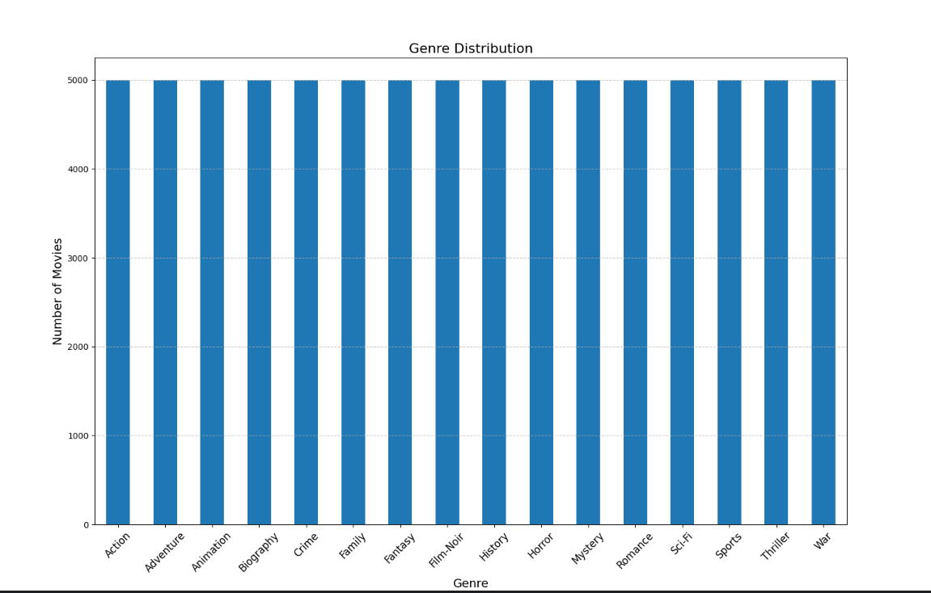

Figure 1.3: Covariance Matrix of Standardized Data

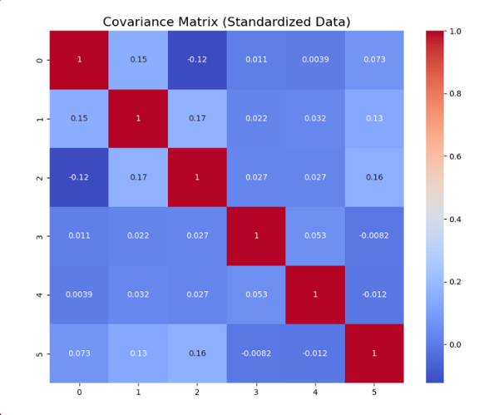

Figure 1.4: Correlation Matrix of Standardized Data

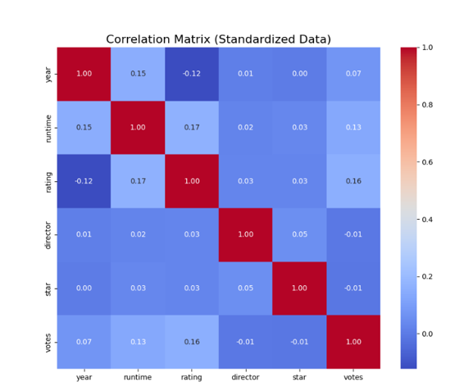

Phase II

Regression model was used to predict continuous value “rating” based on other features. The data was split to an 80:20 ratio with a training set of 80% of the data and testing set with 20% of the data.   
Statistical Analysis:

* T-Test: Done T test analysis
* F-Test: Found F test score to be high which proves these data is statistically important
* Confidence Interval: Found the confidence interval for each data

Figure 2.1: T-test and Confidence Interval

Stepwise Regression was done with backward elimination to find the important features. After stepwise regression 11 features were selected.  
Evaluation Metrices:

* R Squared: 0.123
* Adjusted R Squared: 0.123
* AIC: 1.937e+05
* BIC: 1.938e+05

Figure 2.2: Evaluation Metrics for Stepwise Regression

The model has the same value as R-squared and Adj. R-squared, which proves adding value does not affect the model significantly. Moreover, the low R-squared shows that the model cannot properly explain the variance of the model. While the model is statistically significant according to the F-test, it does not explain the variance of the dependent variable which may be because the predictor and dependent variables are not linear.

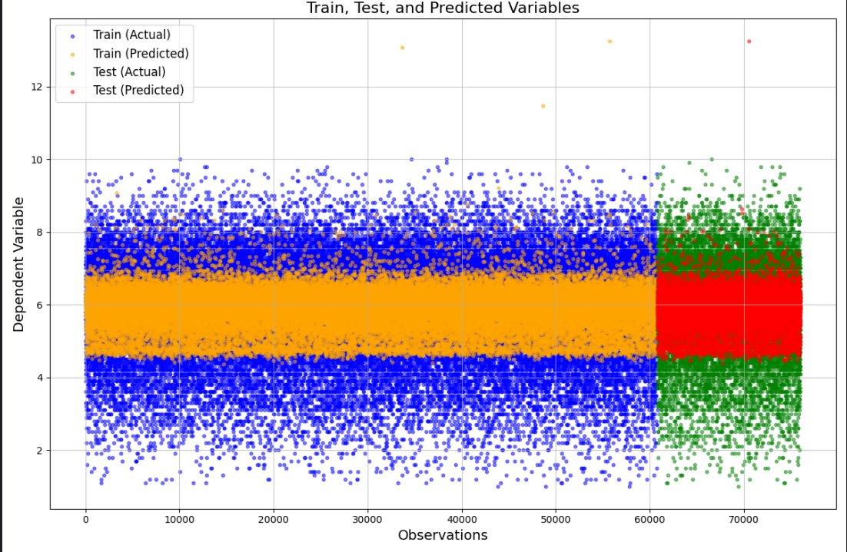

Figure 2.3: Final Look at the model

Phase III

Classification model was used to classify “genre”. “genre” has multiple classes and multiclass classifications was implemented. Training and testing set had 80:20 ratio of data.

* Decision Tree:
  + Base Model: base model had accuracy of 28.85%
  + Pre-pruning: pre-pruned tree had accuracy of 29%
  + Optimal Parameters: used grid search to find the best parameters to use on pre-pruned tree.
  + Post-pruning: first found the optimal ccp_alpha =0, as a result have same result for both pre- and post-pruning. Also, found out how ccp_alpha affects the train and test set (Figure 3.1.0).
  + Confusion Matrix (Figure 3.1.1): Displayed the confusion matrix as shown in the figure (Figure 3.1.1) below. The diagonal values show the true positive values.
  + Classification Report (Figure 3.1.2): For each class (class 0-15) classification report shows the precision, recall, F-1 score and support behind it.
  + ROC Curve and AUC (Figure 3.1.3): To assess the model’s discriminatory abilities, ROC Curve and AUC score were produced.
  + Stratified K-Fold Cross Validation (Figure 3.1.4): Chose k= 5, showed mean accuracy and standard deviation.

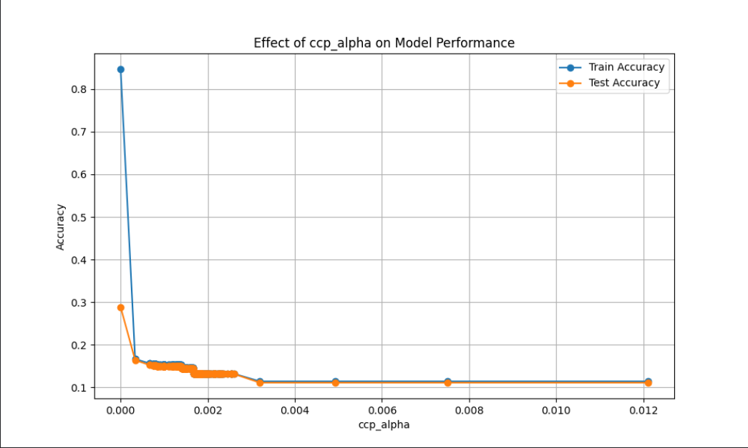Figure 3.0.0: Effects of CCP_alpha on the model

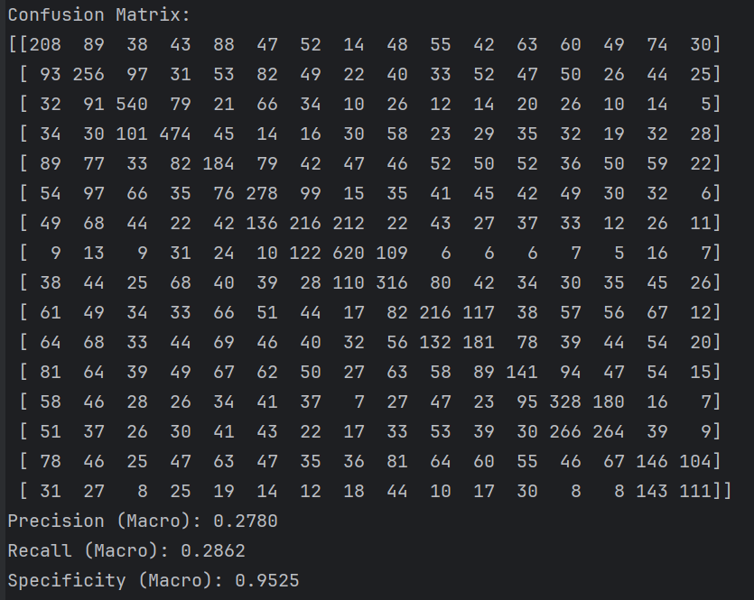

Figure 3.1.1: Confusion Matrix For both Pre and Post pruned model

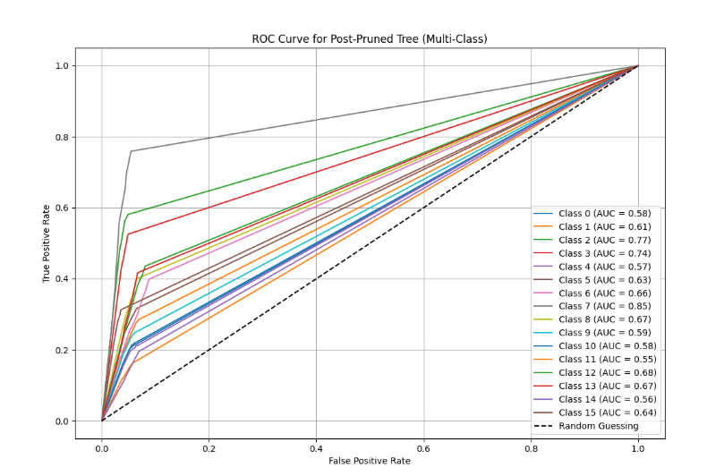

Figure 3.1.2.0: Pre-pruned model ROC AUC Curve

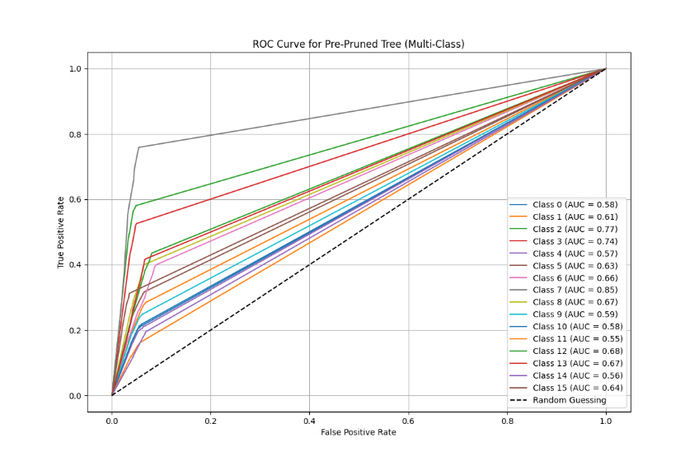

Figure 3.1.2.1: Post-pruned model ROC AUC Curve

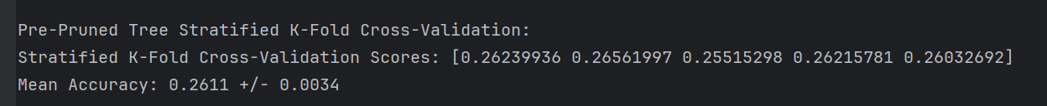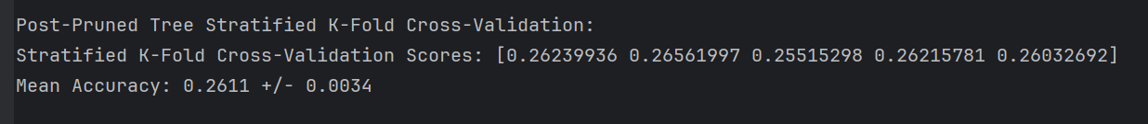

Figure 3.1.3: K-fold Cross Validation

For decision tree the pre and post pruned decision tree both have same values in the evaluation matrices because the optimum ccp_alpha was 0. For ROC Curve every class has an AUC value greater than 0.50. As a result, the ROC Curve is above the 50% line. Class 7 has the highest AUC value and class 11 has the lowest AUC value.

The decision tree model overall has 29% accuracy.

* Logistic Regression
  + Confusion Matrix (Figure 3.2.1): Displayed the confusion matrix as shown in the figure (Figure 3.2.1) below. The diagonal values show the true positive values.
  + Classification Report (Figure 3.2.2): For each class (class 0-15) classification report shows the precision, recall, F-1 score and support behind it.
  + ROC Curve and AUC (Figure 3.2.3): To assess the model’s discriminatory abilities, ROC Curve and AUC score were produced.
  + Stratified K-Fold Cross Validation (Figure 3.2.4): Chose k= 5, showed mean accuracy and standard deviation.  
    A diagram of a confused matrix

    Description automatically generated

Figure 3.2.1: Logistic Regression Confusion Matrix

Figure 3.2.2: Logistic Regression Classification Report

Figure 3.2.3: Logistic Regression ROC Curve with AUC Values

Figure 3.2.4: Logistic Regression K-Fold Cross Validation

For logistic regression model, the accuracy of 16% was gained. The classification report shows precision, recall and F-1 score for each class. As a multi-label classification, the macro-AUC is 0.64 and in the ROC curve every class has an AUC over 0.50.

* KNN:
  + Used Elbow Method to find the best K which was 1, K was searched from 1 to 50 (Figure 3.3.0).
  + Confusion Matrix (Figure 3.3.1): Displayed the confusion matrix as shown in the figure (Figure 3.3.1) below. The diagonal values show the true positive values.
  + Classification Report (Figure 3.3.2): For each class (class 0-15) classification report shows the precision, recall, F-1 score and support behind it.
  + ROC Curve and AUC (Figure 3.3.3): To assess the model’s discriminatory abilities, ROC Curve and AUC score were produced.
  + Stratified K-Fold Cross Validation (Figure 3.3.4): Chose k= 5, showed mean accuracy and standard deviation.

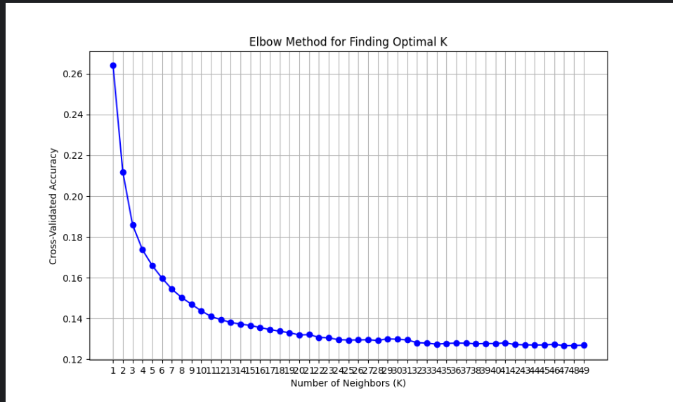

Figure 3.3.0: Finding optimum k

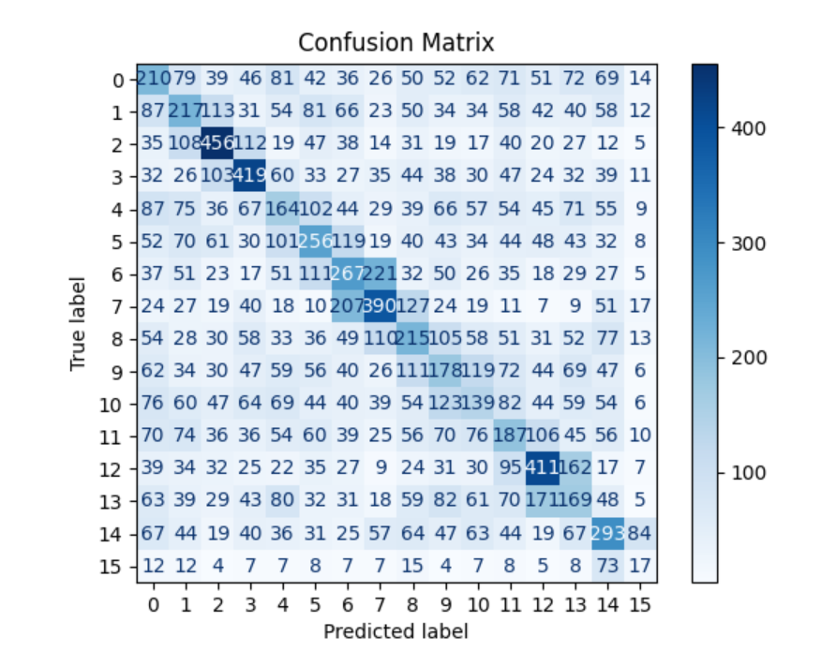  
  
 Figure 3.3.1: KNN Confusion Matrix

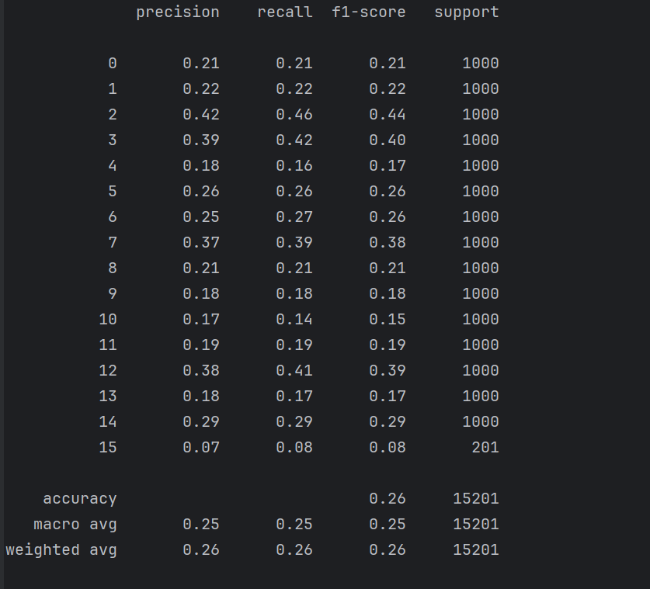 Figure 3.3.2: KNN Classification Report

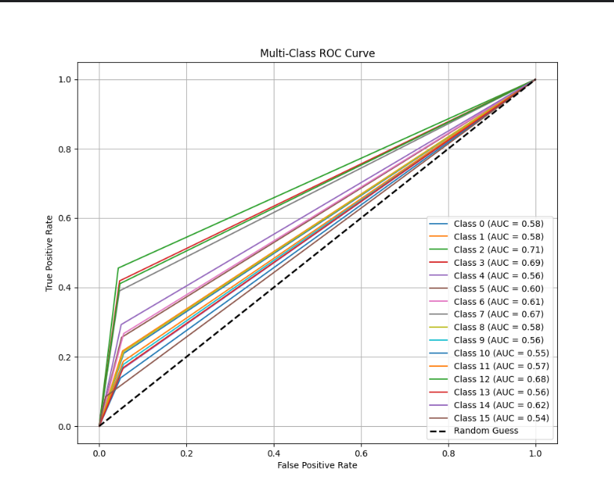

Figure 3.3.3: KNN ROC Curve

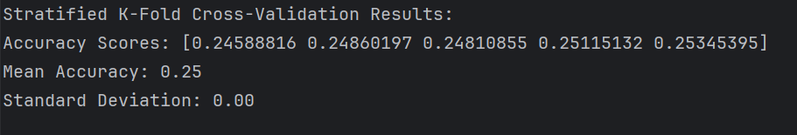

Figure 3.3.4: KNN K-Fold Cross Validation

For KNN, k is 1 after searching for k using elbow method. Using the optimum k, the accuracy of KNN is 26% and for each class the precision, recall and F-1 score is shown for every class. The mean accuracy after 5-fold is 25% with a standard deviation of 0.00. For each fold the accuracy score is also shown in the figure (3.3.4). The roc curve shows class-2 has the highest AUC value of 0.71 and class-15 has the lowest AUC value of 0.54.

* SVM
  + Linear Kernel: accuracy of 14%
    - Classification Report (Figure 3.4.1)
    - ROC Curve with AUC Score (Figure 3.4.2)
    - K-Fold Cross Validation (3.4.3)

Figure 3.4.1: SVM Linear Kernel Classification Report

Figure 3.4.2: SVM Linear Kernel ROC Curve with AUC Score

Figure 3.4.3: SVM kernel K-Fold Cross Validation

* + Polynomial Kernel: accuracy of 14%
    - Classification Report (Figure 3.4.4)
    - ROC Curve with AUC Score (Figure 3.4.5)
    - K-Fold Cross Validation (3.4.6)

Figure 3.4.4: SVM Polynomial Kernel Classification Report

Figure 3.4.5: Polynomial Kernel ROC curve with AUC Score

Figure 3.4.6: Polynomial Kernel K-Fold Cross Validation

* + RBF Kernel:
    - Classification Report (Figure 3.4.7)
    - ROC Curve with AUC Score (Figure 3.4.8)
    - K-Fold Cross Validation (3.4.9)

Figure 3.4.7: RBF Classification Report

Figure 3.4.8: RBF ROC Curve with AUC Score

Figure 3.4.9: RBF K-Fold Cross Validation

For SVM, linear kernel and polynomial kernel have the same accuracy of 14% whereas RBF kernel has 12% accuracy. In the ROC Curve for every kernel class 7 had the highest accuracy. Macro AUC for all the kernel is above 0.50 and as a result, the ROC curve is above 50% line.

5-fold cross validation shows and there are not that much improvement.

* Naïve Bayes
  + Classification Report (Figure 3.5.1): For each class (class 0-15) classification report shows the precision, recall, F-1 score and support behind it.
  + ROC Curve and AUC (Figure 3.5.2): To assess the model’s discriminatory abilities, ROC Curve and AUC score were produced.
  + Stratified K-Fold Cross Validation (Figure 3.5.3): Chose k= 5, showed mean accuracy and standard deviation.

1. K-Fold Accuracy Scores: [0.10209854614827972, 0.09769736842105263, 0.10026315789473685, 0.09907894736842106, 0.10236842105263158]
2. Mean Accuracy: 0.10,
3. K-Fold AUC Scores: [np.float64(0.5769371438766837), np.float64(0.5772191355633802), np.float64(0.5795489460093897), np.float64(0.5760854901701877), np.float64(0.5788754881161973)]
4. Mean AUC: 0.58
5. Standard Deviation: 0.00

So, overall, Naïve Bayes have the accuracy of 10% which basically proves the model performs very bad in this model.

Phase IV

In phase IV, clustering and association rule mining were implemented. As a result, there is no target variable, and model was used on the whole dataset.

Clustering:

For clustering,2 algorithms were used to uncover patterns in data:

* K-Means Clustering: For K-Means clustering, PCA was used to reduce the dimensionality of the data. After reducing the dimensionality there were only 2 principal components which explained more than 95% of the variance. silhouette analysis was done to find the optimum K. The optimum value of K was 2 (Figure 4.1.1, Figure 4.1.2). After that, the final figure (Figure 4.1.3) shows the final clusters for the model.  
  A graph with orange lines

  Description automatically generated

Figure 4.1.1: Silhouette Analysis

Figure 4.1.2: Elbow Method to find K

Figure 4.1.2: Within Plot for K Means

* DBSCAN Algorithm: To use DBSCAN algorithm, first the number of eps needed to be determined. Initially, the min sample was chosen to be 2 and later it was updated to 5. As a result, K = 4 because K=min sample -1. According to the figure (Figure 4.2.1), by using K-distance graph the number of eps was found to be 800. Using these values, the final model had 3 clusters and 30 noises (Figure 4.2.2).

Figure 4.2.1: K-distance graph to find eps

Figure 4.2.2: Final Model DBSCAN

Association Rule Mining

The Apriori Algorithm was used to manifest meaningful rules between the features. First, SVD was used for dimensionality reduction technique as it works perfectly for this algorithm. After that, to binarize the value, values which are greater than 0 were replaced by 1 and values under 0 were replaced by 0 (Figure 4.3.1). After that, frequent item sets were found with 36 combinations (Figure 4.3.2) which were later used to get the association rules (Figure 4.3.3). According to the figure (Figure 4.3.3), the first few have high confidence and support. Lastly, the support vs confidence graph was plotted (Figure 4.3.4).

Figure 4.3.1: Binarize the Data

Figure 4.3.2: frequent item set

Figure 4.3.3: Association Rules

Figure 4.3.4: Support vs Confidence graph

Recommendations

* Feature Engineering and Data pre-processing is an important part of any machine learning model and needs to be done more thoroughly.
* For future improvements, I would love to work with a proper machine which is computationally powerful for the models so that I can research more thoroughly.
* The classification models are computationally expensive and it was hard to run these in my machine which is why I could not research for further improvement for the predictions.

Appendix

Appendix A: Important Libraries

import numpy as np  
import pandas as pd  
import matplotlib.pyplot as plt  
import seaborn as sns  
import plotly.graph_objects as go  
import plotly.express as px  
from statsmodels.tools import categorical  
from prettytable import PrettyTable  
import re  
import time  
from sklearn.decomposition import PCA  
from sklearn.model_selection import train_test_split  
from sklearn.preprocessing import StandardScaler  
from sklearn.linear_model import LinearRegression  
from sklearn.ensemble import RandomForestClassifier  
from scipy import stats

Appendix B: Python Code for Data Cleaning and Preprocessing

#%% Dataset  
df = pd.read_csv('Machine Learning Term Project/combined_genres.csv')  
print(df.head())  
#%% Duplicate Values  
print(f' Before Removing Duplicates {df.duplicated().sum()}')  
df = df.drop_duplicates()  
print(f' After Removing Duplicates {df.duplicated().sum()}')  
#%% Null Values with dtypes  
null_info = pd.DataFrame({  
 'Null Values': df.isnull().sum(),  
 'Null Percentage': (df.isnull().sum() / len(df)) * 100,  
 'Data Type': df.dtypes  
})  
print(null_info)  
#%% Handling Unwanted and NUll Values  
unwanted_values = ['I', 'II', 'V', 'III', 'VII', 'IV', 'XXIII', 'IX', 'XV', 'VI', 'X', 'XIV', 'XIX', 'XXIX', 'XXI', 'VIII', 'XI', 'XVIII', 'XII', 'XIII', 'LXXI', 'XVI', 'XX', 'XXXIII', 'XXXII', 'XXXVI', 'XVII', 'LXIV', 'LXII', 'LXVIII', 'XL', 'XXXIV', 'XXXI', 'XLV', 'XLIV', 'XXIV', 'XXVII', 'LX', 'XXV', 'XXXIX', '2029', 'XXVIII', 'XXX', 'LXXII', '1909', 'XXXVIII', 'XXII', 'LVI', 'LVII' 'XLI', 'LII', 'XXXVII', 'LIX', 'LVIII', 'LXX', 'XLIII', 'XLIX', 'LXXIV', 'XXVI', 'C', 'XLI', 'LVII', 'LV','XLVI', 'LXXVII', 'XXXV', 'LIV', 'LI', 'LXXXII', 'XCIX', 'LXIII']  
  
df = df[~df['year'].astype(str).isin(unwanted_values)]  
df['year'] = pd.to_numeric(df['year'], errors='coerce')  
df = df.dropna(subset=['year'])  
df['year'] = df['year'].astype(int)  
#%% Clean runtime  
def clean_runtime(runtime):  
 try:  
  
 return float(re.findall(r'\d+', str(runtime))[0])  
 except (IndexError, ValueError):  
 return None  
  
df['runtime'] = df['runtime'].apply(clean_runtime)  
df = df.dropna(subset=['runtime'])  
df['runtime'] = df['runtime'].astype(float)  
#%% Clean director and stars  
def clean_string(value):  
 if pd.isnull(value):  
 return value  
 return str(value).strip()  
df['director'] = df['director'].str.replace('\n', '')  
df['star'] = df['star'].str.replace('\n', '')  
df['director'] = df['director'].apply(clean_string)  
df['star'] = df['star'].apply(clean_string)  
  
print(df[['director', 'star']].head())  
#%%  
df =df.dropna(subset=['director','star'])  
#%%  
df = df.dropna(subset=['votes', 'rating'])  
print(f"New dataset shape: {df.shape}")  
  
  
#%% Dropping columns with no importance  
df = df.drop(columns=['movie_id', 'director_id', 'star_id', 'description'])  
print(df.head())  
#%% Dropping columns with more than 50% null values  
df =df.drop(columns=['certificate','gross(in $)'])  
  
#%% Aggregation  
  
#%% Before Upsampling and Downsampling  
genre_counts = df['genre'].value_counts()  
  
plt.figure(figsize=(16, 10))  
genre_counts.plot(kind='bar')  
plt.title('Genre Distribution', fontsize=16)  
plt.xlabel('Genre', fontsize=14)  
plt.ylabel('Number of Movies', fontsize=14)  
plt.xticks(rotation=45, fontsize=12)  
plt.grid(axis='y', linestyle='--', alpha=0.7)  
plt.show()  
#%% Upsample and Downsample  
film_noir_data = df[df['genre'] == 'Film-Noir']  
film_noir_upsampled = film_noir_data.sample(n=5000, random_state=42, replace=True)  
  
# Downsample the top 15 genres to 5000 samples  
top_15_genres = df['genre'].value_counts().index[:15]  
downsampled_data = pd.concat([  
 x.sample(n=5000, random_state=42) if len(x) >= 5000 else x  
 for _, x in df[df['genre'].isin(top_15_genres)].groupby('genre')  
]).reset_index(drop=True)  
balanced_data = pd.concat([downsampled_data, film_noir_upsampled], ignore_index=True)  
print(f"Balanced dataset shape: {balanced_data.shape}")  
print(balanced_data['genre'].value_counts())  
#%%  
balanced_data = pd.concat([  
 x.sample(n=5000, random_state=42, replace=True)  
 for _, x in df.groupby('genre')  
]).reset_index(drop=True)  
  
# Display the shape of the new balanced dataset  
print(f"Balanced dataset shape: {balanced_data.shape}")  
print(balanced_data['genre'].value_counts())  
#%%  
genre_counts = balanced_data['genre'].value_counts()  
  
plt.figure(figsize=(16, 10))  
genre_counts.plot(kind='bar')  
plt.title('Genre Distribution', fontsize=16)  
plt.xlabel('Genre', fontsize=14)  
plt.ylabel('Number of Movies', fontsize=14)  
plt.xticks(rotation=45, fontsize=12)  
plt.grid(axis='y', linestyle='--', alpha=0.7)  
plt.show()  
#%%  
balanced_data = balanced_data.drop(columns =['movie_name'])  
#%%  
df_cleaned = balanced_data.copy()  
  
#%% Encoding  
from sklearn.preprocessing import LabelEncoder  
  
y = df_cleaned['genre']  
X = df_cleaned.drop(columns=['genre'])  
  
label_encoder = LabelEncoder()  
for col in X.select_dtypes(include=['object']).columns:  
 X[col] = label_encoder.fit_transform(X[col].astype(str))  
y = label_encoder.fit_transform(y)  
  
#%%  
from sklearn.preprocessing import StandardScaler, MinMaxScaler  
  
scaler = StandardScaler()  
X_standardized = scaler.fit_transform(X)  
X_standardized_df = pd.DataFrame(X_standardized, columns=X.columns)  
print("Standardized Features:")  
print(X_standardized_df.head())  
#%%  
cov_matrix = np.cov(X_standardized_df, rowvar=False)  
plt.figure(figsize=(10, 8))  
sns.heatmap(cov_matrix, annot=True, cmap='coolwarm', cbar=True)  
plt.title('Covariance Matrix (Standardized Data)', fontsize=16)  
plt.show()  
#%%  
corr_matrix = X_standardized_df.corr()  
plt.figure(figsize=(10, 8))  
sns.heatmap(corr_matrix, annot=True, fmt=".2f", cmap='coolwarm', cbar=True)  
plt.title('Correlation Matrix (Standardized Data)', fontsize=16)  
plt.show()  
#%%  
normalizer = MinMaxScaler()  
X_normalized = normalizer.fit_transform(X)  
X_normalized_df = pd.DataFrame(X_normalized, columns=X.columns)  
print("\nNormalized Features:")  
print(X_normalized_df.head())  
  
  
  
#%%  
  
from statsmodels.stats.outliers_influence import variance_inflation_factor  
from sklearn.decomposition import PCA, TruncatedSVD  
from sklearn.ensemble import RandomForestRegressor  
def calculate_vif(X):  
 vif_data = pd.DataFrame()  
 vif_data['Feature'] = X.columns  
 vif_data['VIF'] = [variance_inflation_factor(X.values, i) for i in range(X.shape[1])]  
 return vif_data  
  
vif_standardized = calculate_vif(X_standardized_df)  
print("VIF Before Removal (Standardized):")  
print(vif_standardized)  
  
high_vif_features = vif_standardized[vif_standardized['VIF'] > 10]['Feature']  
X_standardized_reduced = X_standardized_df.drop(columns=high_vif_features)  
  
# Recalculate VIF after removal  
vif_standardized_reduced = calculate_vif(X_standardized_reduced)  
print("VIF After Removal (Standardized):")  
print(vif_standardized_reduced)  
  
pca = PCA(n_components=0.95)  
X_pca = pca.fit_transform(X_standardized_reduced)  
explained_variance = pca.explained_variance_ratio_  
print("PCA Explained Variance Ratio:", explained_variance)  
print("PCA Shape After Reduction:", X_pca.shape)  
rf_regressor = RandomForestRegressor(random_state=42)  
rf_regressor.fit(X_standardized_reduced, y)  
feature_importances = pd.DataFrame({  
 'Feature': X_standardized_reduced.columns,  
 'Importance': rf_regressor.feature_importances_  
}).sort_values(by='Importance', ascending=False)  
  
print("Random Forest Feature Importance:")  
print(feature_importances)  
  
top_features = feature_importances.head(10)['Feature']  
X_rf_selected = X_standardized_reduced[top_features]  
  
svd = TruncatedSVD(n_components=6, random_state=42)  
X_svd = svd.fit_transform(X_standardized_reduced)  
print("SVD Shape After Reduction:", X_svd.shape)  
  
print("\nFinal Selected Features (VIF and RF Importance):", X_rf_selected.columns.tolist())  
print("\nFinal PCA Components Shape:", X_pca.shape)  
print("\nFinal SVD Components Shape:", X_svd.shape)  
  
#%%  
vif_normalized = calculate_vif(X_normalized_df)  
print("\nVIF Before Removal (Normalized):")  
print(vif_normalized)  
  
high_vif_features = vif_normalized[vif_normalized['VIF'] > 10]['Feature']  
X_normalized_reduced = X_normalized_df.drop(columns=high_vif_features)  
vif_normalized_reduced = calculate_vif(X_normalized_reduced)  
print("\nVIF After Removal (Normalized):")  
print(vif_normalized_reduced)  
  
pca = PCA(n_components=0.95)  
X_pca_normalized = pca.fit_transform(X_normalized_reduced)  
explained_variance_normalized = pca.explained_variance_ratio_  
print("\nPCA Explained Variance Ratio (Normalized):", explained_variance_normalized)  
print("PCA Shape After Reduction (Normalized):", X_pca_normalized.shape)  
  
rf_regressor = RandomForestRegressor(random_state=42)  
rf_regressor.fit(X_normalized_reduced, y)  
feature_importances_normalized = pd.DataFrame({  
 'Feature': X_normalized_reduced.columns,  
 'Importance': rf_regressor.feature_importances_  
}).sort_values(by='Importance', ascending=False)  
  
print("\nRandom Forest Feature Importance (Normalized):")  
print(feature_importances_normalized)  
  
top_features_normalized = feature_importances_normalized.head(10)['Feature']  
X_rf_selected_normalized = X_normalized_reduced[top_features_normalized]  
  
svd = TruncatedSVD(n_components=4, random_state=42)  
X_svd_normalized = svd.fit_transform(X_normalized_reduced)  
print("\nSVD Shape After Reduction (Normalized):", X_svd_normalized.shape)  
print("\nFinal Selected Features (VIF and RF Importance, Normalized):", X_rf_selected_normalized.columns.tolist())  
print("\nFinal PCA Components Shape (Normalized):", X_pca_normalized.shape)  
print("\nFinal SVD Components Shape (Normalized):", X_svd_normalized.shape)

#%%  
from sklearn.neighbors import LocalOutlierFactor  
from sklearn.ensemble import IsolationForest  
from sklearn.cluster import DBSCAN  
from scipy.stats import zscore  
  
  
def detect_and_remove_outliers(method, data, **kwargs):  
  
 if method == 'lof':  
 n_neighbors = kwargs.get('n_neighbors', 20)  
 contamination = kwargs.get('contamination', 0.05)  
 lof = LocalOutlierFactor(n_neighbors=n_neighbors, contamination=contamination)  
 outlier_labels = lof.fit_predict(data)  
 return data[outlier_labels == 1]  
  
 elif method == 'isolation_forest':  
 contamination = kwargs.get('contamination', 0.05)  
 random_state = kwargs.get('random_state', 42)  
 iso_forest = IsolationForest(contamination=contamination, random_state=random_state)  
 outlier_labels = iso_forest.fit_predict(data)  
 return data[outlier_labels == 1]  
  
 elif method == 'dbscan':  
 eps = kwargs.get('eps', 0.5)  
 min_samples = kwargs.get('min_samples', 5)  
 dbscan = DBSCAN(eps=eps, min_samples=min_samples)  
 cluster_labels = dbscan.fit_predict(data)  
 return data[cluster_labels != -1] # Keep only non-outlier points  
  
 elif method == 'zscore':  
 threshold = kwargs.get('threshold', 3)  
 z_scores = np.abs(zscore(data))  
 outlier_mask = (z_scores < threshold).all(axis=1) # Identify rows where all features are below threshold  
 return data[outlier_mask]  
  
 else:  
 raise ValueError("Invalid method. Choose 'lof', 'isolation_forest', 'dbscan', or 'zscore'.")  
  
  
  
X_lof_cleaned = detect_and_remove_outliers('lof', X_rf_selected, n_neighbors=20, contamination=0.05)  
print(f"Shape after LOF outlier removal: {X_lof_cleaned.shape}")  
  
X_iso_cleaned = detect_and_remove_outliers('isolation_forest', X_rf_selected, contamination=0.05, random_state=42)  
print(f"Shape after Isolation Forest outlier removal: {X_iso_cleaned.shape}")  
  
X_dbscan_cleaned = detect_and_remove_outliers('dbscan', X_rf_selected, eps=0.5, min_samples=5)  
print(f"Shape after DBSCAN outlier removal: {X_dbscan_cleaned.shape}")  
  
X_zscore_cleaned = detect_and_remove_outliers('zscore', X_rf_selected, threshold=3)  
print(f"Shape after Z-score outlier removal: {X_zscore_cleaned.shape}")  
  
#%%  
  
X_lof_cleaned_normalized = detect_and_remove_outliers('lof', X_rf_selected_normalized, n_neighbors=20, contamination=0.05)  
print(f"Shape after LOF outlier removal (Normalized): {X_lof_cleaned_normalized.shape}")  
  
X_iso_cleaned_normalized = detect_and_remove_outliers('isolation_forest', X_rf_selected_normalized, contamination=0.05, random_state=42)  
print(f"Shape after Isolation Forest outlier removal (Normalized): {X_iso_cleaned_normalized.shape}")  
  
X_dbscan_cleaned_normalized = detect_and_remove_outliers('dbscan', X_rf_selected_normalized, eps=0.5, min_samples=5)  
print(f"Shape after DBSCAN outlier removal (Normalized): {X_dbscan_cleaned_normalized.shape}")  
  
X_zscore_cleaned_normalized = detect_and_remove_outliers('zscore', X_rf_selected_normalized, threshold=3)  
print(f"Shape after Z-score outlier removal (Normalized): {X_zscore_cleaned_normalized.shape}")

Appendix C: Regression Analysis

#%% Linear Regression Model  
from sklearn.linear_model import LinearRegression  
from sklearn.metrics import mean_squared_error, r2_score  
import statsmodels.api as sm  
  
X_train_sm = sm.add_constant(X_train)  
X_test_sm = sm.add_constant(X_test)  
  
model = sm.OLS(y_train, X_train_sm).fit()  
  
y_pred_train = model.predict(X_train_sm)  
y_pred_test = model.predict(X_test_sm)  
  
mse = mean_squared_error(y_test, y_pred_test)  
r_squared = r2_score(y_test, y_pred_test)  
adjusted_r_squared = 1 - (1 - r_squared) * (len(y_test) - 1) / (len(y_test) - X_test.shape[1] - 1)  
aic = model.aic  
bic = model.bic  
  
evaluation_table = pd.DataFrame({  
 "Metric": ["R-squared", "Adjusted R-squared", "AIC", "BIC", "MSE"],  
 "Value": [r_squared, adjusted_r_squared, aic, bic, mse]  
})  
print(evaluation_table)  
  
#%% T-test and F-test  
print("T-Test Results:")  
print(model.t_test(np.identity(len(model.params))))  
  
print("\nF-Test Results:")  
print(model.f_test(np.identity(len(model.params))))  
  
#%% Confidence Interval Analysis  
confidence_intervals = model.conf_int()  
print("\nConfidence Intervals:")  
print(confidence_intervals)  
  
#%% Stepwise Regression  
X_train_reset = pd.DataFrame(X_train).reset_index(drop=True)  
y_train_reset = pd.Series(y_train).reset_index(drop=True)  
  
def stepwise_selection(X, y, initial_list=[], threshold_in=0.01, threshold_out=0.05, verbose=True):  
 included = list(initial_list)  
 while True:  
 changed = False  
 excluded = list(set(X.columns) - set(included))  
 new_pval = pd.Series(index=excluded, dtype=float)  
 for new_col in excluded:  
 model = sm.OLS(y, sm.add_constant(X[included + [new_col]])).fit()  
 new_pval[new_col] = model.pvalues[new_col]  
 best_pval = new_pval.min()  
 if best_pval < threshold_in:  
 best_feature = new_pval.idxmin()  
 included.append(best_feature)  
 changed = True  
 if verbose:  
 print(f"Add {best_feature} with p-value {best_pval}")  
  
 model = sm.OLS(y, sm.add_constant(X[included])).fit()  
 pvalues = model.pvalues.iloc[1:]  
 worst_pval = pvalues.max()  
 if worst_pval > threshold_out:  
 changed = True  
 worst_feature = pvalues.idxmax()  
 included.remove(worst_feature)  
 if verbose:  
 print(f"Drop {worst_feature} with p-value {worst_pval}")  
  
 if not changed:  
 break  
 return included  
selected_features = stepwise_selection(X_train_reset, y_train_reset)  
  
print("\nSelected Features via Stepwise Regression:")  
print(selected_features)

Appendix D: Classification Analysis

#%% Baseline DT model  
from sklearn.tree import DecisionTreeClassifier  
from sklearn.metrics import accuracy_score  
  
baseline_tree = DecisionTreeClassifier(random_state=42)  
baseline_tree.fit(X_train, y_train)  
  
y_pred = baseline_tree.predict(X_test)  
print(f"Baseline Accuracy: {accuracy_score(y_test, y_pred)}")  
  
#%% Pre-Pruning  
from sklearn.model_selection import GridSearchCV  
  
param_grid = {  
 'criterion': ['gini', 'entropy'],  
 'splitter': ['best', 'random'],  
 'max_depth': [5, 10, 15, None],  
 'min_samples_split': [2, 5, 10],  
 'min_samples_leaf': [1, 2, 4],  
 'max_features': [None, 'sqrt', 'log2'],  
}  
  
grid_search = GridSearchCV(  
 estimator=DecisionTreeClassifier(random_state=42),  
 param_grid=param_grid,  
 scoring='accuracy',  
 cv=5,  
 n_jobs=-1  
)  
  
grid_search.fit(X_train, y_train)  
  
best_params = grid_search.best_params_  
best_tree = grid_search.best_estimator_  
print(f"Best Parameters: {best_params}")  
#%%  
from sklearn.metrics import classification_report, accuracy_score  
pre_pruned_tree = DecisionTreeClassifier(  
 random_state=42,  
 criterion=best_params['criterion'],  
 splitter=best_params['splitter'],  
 max_depth=best_params['max_depth'],  
 min_samples_split=best_params['min_samples_split'],  
 min_samples_leaf=best_params['min_samples_leaf'],  
 max_features=best_params['max_features']  
)  
  
pre_pruned_tree.fit(X_train, y_train)  
  
y_pred = pre_pruned_tree.predict(X_test)  
  
print(f"Accuracy: {accuracy_score(y_test, y_pred)}")  
print("\nClassification Report:")  
print(classification_report(y_test, y_pred))  
#%%  
from sklearn.tree import DecisionTreeClassifier  
X_t = X_train[:1000]  
y_t = y_train[:1000]  
path = DecisionTreeClassifier(random_state=42).cost_complexity_pruning_path(X_t,y_t)  
ccp_alphas = path.ccp_alphas  
impurities = path.impurities  
ccp_alphas = ccp_alphas[ccp_alphas >= 0]  
#%%  
trees = []  
for alpha in ccp_alphas:  
 tree = DecisionTreeClassifier(random_state=42, ccp_alpha=alpha)  
 tree.fit(X_train, y_train)  
 trees.append(tree)  
  
  
#%%  
from sklearn.metrics import accuracy_score  
  
train_scores = [accuracy_score(y_train, tree.predict(X_train)) for tree in trees]  
test_scores = [accuracy_score(y_test, tree.predict(X_test)) for tree in trees]  
  
import matplotlib.pyplot as plt  
  
plt.figure(figsize=(10, 6))  
plt.plot(ccp_alphas, train_scores, label="Train Accuracy", marker='o')  
plt.plot(ccp_alphas, test_scores, label="Test Accuracy", marker='o')  
plt.xlabel("ccp_alpha")  
plt.ylabel("Accuracy")  
plt.title("Effect of ccp_alpha on Model Performance")  
plt.legend()  
plt.grid(True)  
plt.show()  
  
#%%  
optimal_ccp_alpha = ccp_alphas[np.argmax(test_scores)]  
print(f"Optimal ccp_alpha: {optimal_ccp_alpha}")  
  
#%%  
post_pruned_tree = DecisionTreeClassifier(random_state=42, ccp_alpha=optimal_ccp_alpha)  
post_pruned_tree.fit(X_train, y_train)  
#%%  
from sklearn.metrics import confusion_matrix, precision_score, recall_score, f1_score, roc_curve, auc, roc_auc_score  
from sklearn.model_selection import StratifiedKFold, cross_val_score  
import matplotlib.pyplot as plt  
import numpy as np  
  
#%%  
def calculate_specificity_multiclass(y_true, y_pred, average='macro'):  
 cm = confusion_matrix(y_true, y_pred)  
 specificity_per_class = []  
 for i in range(len(cm)):  
 tn = np.sum(cm) - (np.sum(cm[i, :]) + np.sum(cm[:, i]) - cm[i, i])  
 fp = np.sum(cm[:, i]) - cm[i, i]  
 specificity_per_class.append(tn / (tn + fp) if (tn + fp) > 0 else 0)  
 if average == 'macro':  
 return np.mean(specificity_per_class)  
 elif average == 'weighted':  
 weights = np.sum(cm, axis=1) / np.sum(cm)  
 return np.sum(specificity_per_class * weights)  
  
#%%  
def evaluate_model(model, X_test, y_test):  
 y_pred = model.predict(X_test)  
 y_prob = model.predict_proba(X_test)  
  
  
 cm = confusion_matrix(y_test, y_pred)  
 print("Confusion Matrix:")  
 print(cm)  
  
  
 precision = precision_score(y_test, y_pred, average='macro')  
 recall = recall_score(y_test, y_pred, average='macro')  
 f1 = f1_score(y_test, y_pred, average='macro')  
 specificity = calculate_specificity_multiclass(y_test, y_pred, average='macro')  
  
 print(f"Precision (Macro): {precision:.4f}")  
 print(f"Recall (Macro): {recall:.4f}")  
 print(f"Specificity (Macro): {specificity:.4f}")  
 print(f"F1-Score (Macro): {f1:.4f}")  
  
  
 roc_auc = roc_auc_score(y_test, y_prob, multi_class='ovr', average='macro')  
  
 print(f"AUC (Macro): {roc_auc:.4f}")  
#%%  
evaluate_model(pre_pruned_tree, X_test, y_test)  
#%%  
evaluate_model(post_pruned_tree, X_test, y_test)  
  
#%%  
from sklearn.preprocessing import label_binarize  
y_prob_pre_pruned = pre_pruned_tree.predict_proba(X_test)  
y_prob_post_pruned = post_pruned_tree.predict_proba(X_test)  
  
classes = np.unique(y_test)  
y_test_binarized = label_binarize(y_test, classes=classes)  
  
fpr_pre, tpr_pre, roc_auc_pre = {}, {}, {}  
for i in range(len(classes)):  
 fpr_pre[i], tpr_pre[i], _ = roc_curve(y_test_binarized[:, i], y_prob_pre_pruned[:, i])  
 roc_auc_pre[i] = auc(fpr_pre[i], tpr_pre[i])  
  
fpr_post, tpr_post, roc_auc_post = {}, {}, {}  
for i in range(len(classes)):  
 fpr_post[i], tpr_post[i], _ = roc_curve(y_test_binarized[:, i], y_prob_post_pruned[:, i])  
 roc_auc_post[i] = auc(fpr_post[i], tpr_post[i])  
  
# Plot ROC-AUC Curve for Pre-Pruned Tree  
plt.figure(figsize=(12, 8))  
for i in range(len(classes)):  
 plt.plot(fpr_pre[i], tpr_pre[i], label=f'Class {classes[i]} (AUC = {roc_auc_pre[i]:.2f})')  
plt.plot([0, 1], [0, 1], 'k--', label='Random Guessing')  
plt.xlabel('False Positive Rate')  
plt.ylabel('True Positive Rate')  
plt.title('ROC Curve for Pre-Pruned Tree (Multi-Class)')  
plt.legend(loc='best')  
plt.grid()  
plt.show()  
  
# Plot ROC-AUC Curve for Post-Pruned Tree  
plt.figure(figsize=(12, 8))  
for i in range(len(classes)):  
 plt.plot(fpr_post[i], tpr_post[i], label=f'Class {classes[i]} (AUC = {roc_auc_post[i]:.2f})')  
plt.plot([0, 1], [0, 1], 'k--', label='Random Guessing')  
plt.xlabel('False Positive Rate')  
plt.ylabel('True Positive Rate')  
plt.title('ROC Curve for Post-Pruned Tree (Multi-Class)')  
plt.legend(loc='best')  
plt.grid()  
plt.show()  
#%%  
def perform_stratified_kfold(model, X, y):  
 skf = StratifiedKFold(n_splits=5, shuffle=True, random_state=42)  
 scores = cross_val_score(model, X, y, cv=skf, scoring='accuracy')  
 print(f"Stratified K-Fold Cross-Validation Scores: {scores}")  
 print(f"Mean Accuracy: {scores.mean():.4f} +/- {scores.std():.4f}")  
  
print("\nPre-Pruned Tree Stratified K-Fold Cross-Validation:")  
perform_stratified_kfold(pre_pruned_tree, X_train, y_train)  
  
print("\nPost-Pruned Tree Stratified K-Fold Cross-Validation:")  
perform_stratified_kfold(post_pruned_tree, X_train, y_train)  
#%% Logistic Regression  
y_zscore_cleaned = y[X_rf_selected.index]  
y_zscore_cleaned = y_zscore_cleaned[:len(X_zscore_cleaned)]  
X_train, X_test, y_train, y_test = train_test_split(  
 X_zscore_cleaned,  
 y_zscore_cleaned,  
 test_size=0.2,  
 random_state=42,  
 stratify=y_zscore_cleaned  
)  
  
print(f"X_train shape: {X_train.shape}, y_train shape: {y_train.shape}")  
print(f"X_test shape: {X_test.shape}, y_test shape: {y_test.shape}")  
  
#%%  
from sklearn.linear_model import LogisticRegression  
from sklearn.metrics import confusion_matrix, ConfusionMatrixDisplay, classification_report, roc_curve, auc  
from sklearn.model_selection import StratifiedKFold, cross_val_score  
import matplotlib.pyplot as plt  
import numpy as np  
  
log_reg = LogisticRegression(random_state=42, max_iter=1000)  
log_reg.fit(X_train, y_train)  
y_pred = log_reg.predict(X_test)  
y_pred_prob = log_reg.predict_proba(X_test)[:, 1]  
  
#%%  
print(y_pred)  
  
#%% Confusion Matrix  
cm = confusion_matrix(y_test, y_pred)  
  
if cm.shape == (2, 2):  
 TN, FP, FN, TP = cm.ravel()  
 precision = TP / (TP + FP) if (TP + FP) > 0 else 0  
 recall = TP / (TP + FN) if (TP + FN) > 0 else 0  
 specificity = TN / (TN + FP) if (TN + FP) > 0 else 0  
 f1_score = 2 * (precision * recall) / (precision + recall) if (precision + recall) > 0 else 0  
  
  
 print("Metrics:")  
 print(f"Precision: {precision:.2f}")  
 print(f"Recall (Sensitivity): {recall:.2f}")  
 print(f"Specificity: {specificity:.2f}")  
 print(f"F1-Score: {f1_score:.2f}")  
  
else:  
 print("Classification Report:")  
 print(classification_report(y_test, y_pred))  
  
#%%  
cm = confusion_matrix(y_test, y_pred)  
disp = ConfusionMatrixDisplay(confusion_matrix=cm, display_labels=np.unique(y_test))  
disp.plot(cmap=plt.cm.Blues)  
plt.title("Confusion Matrix")  
plt.show()  
  
#%%  
from sklearn.metrics import roc_curve, auc, roc_auc_score  
from sklearn.preprocessing import label_binarize  
classes = np.unique(y_test) # Extract the unique classes  
y_test_binarized = label_binarize(y_test, classes=classes)  
y_pred_prob = log_reg.predict_proba(X_test)  
classes = np.unique(y_test) # Extract the unique classes  
y_test_binarized = label_binarize(y_test, classes=classes)  
y_pred_prob = log_reg.predict_proba(X_test)  
fpr = {}  
tpr = {}  
roc_auc = {}  
  
for i, class_label in enumerate(classes):  
 fpr[class_label], tpr[class_label], _ = roc_curve(y_test_binarized[:, i], y_pred_prob[:, i])  
 roc_auc[class_label] = auc(fpr[class_label], tpr[class_label])  
  
fpr_macro, tpr_macro, _ = roc_curve(y_test_binarized.ravel(), y_pred_prob.ravel())  
roc_auc_macro = auc(fpr_macro, tpr_macro)  
plt.figure(figsize=(10, 8))  
for class_label in classes:  
 plt.plot(fpr[class_label], tpr[class_label],  
 label=f"Class {class_label} (AUC = {roc_auc[class_label]:.2f})")  
  
plt.plot(fpr_macro, tpr_macro, label=f"Macro-Average (AUC = {roc_auc_macro:.2f})", linestyle='--', color='black')  
  
plt.plot([0, 1], [0, 1], 'k--', label="Random Guess")  
  
plt.xlabel("False Positive Rate")  
plt.ylabel("True Positive Rate")  
plt.title("Multi-Class ROC-AUC Curve")  
plt.legend(loc="lower right")  
plt.grid(True)  
plt.show()  
roc_auc_macro = roc_auc_score(y_test_binarized, y_pred_prob, average="macro")  
roc_auc_weighted = roc_auc_score(y_test_binarized, y_pred_prob, average="weighted")  
  
print(f"Macro-Average AUC: {roc_auc_macro:.2f}")  
print(f"Weighted-Average AUC: {roc_auc_weighted:.2f}")  
  
#%%  
skf = StratifiedKFold(n_splits=5, shuffle=True, random_state=42)  
#%%  
from sklearn.metrics import make_scorer  
log_reg = LogisticRegression(max_iter=1000, random_state=42, multi_class='ovr')  
cv_accuracy = cross_val_score(log_reg, X_train, y_train, cv=skf, scoring='accuracy')  
  
cv_f1_macro = cross_val_score(log_reg, X_train, y_train, cv=skf,  
 scoring=make_scorer(f1_score, average='macro'))  
  
  
cv_roc_auc_weighted = cross_val_score(log_reg, X_train, y_train, cv=skf,  
 scoring='roc_auc_ovr_weighted')  
  
print("Stratified K-Fold Cross-Validation Results:")  
print(f"Accuracy Scores: {cv_accuracy}")  
print(f"Mean Accuracy: {cv_accuracy.mean():.2f}")  
print(f"Standard Deviation: {cv_accuracy.std():.2f}\n")  
  
print(f"F1 Macro Scores: {cv_f1_macro}")  
print(f"Mean F1 Macro: {cv_f1_macro.mean():.2f}")  
print(f"Standard Deviation: {cv_f1_macro.std():.2f}\n")  
  
print(f"ROC-AUC Weighted Scores: {cv_roc_auc_weighted}")  
print(f"Mean ROC-AUC Weighted: {cv_roc_auc_weighted.mean():.2f}")  
print(f"Standard Deviation: {cv_roc_auc_weighted.std():.2f}\n")  
  
#%% KNN  
y_lof_cleaned_normalized = y[:len(X_lof_cleaned_normalized)]  
from sklearn.model_selection import train_test_split  
  
X_train, X_test, y_train, y_test = train_test_split(  
 X_lof_cleaned_normalized,  
 y_lof_cleaned_normalized,  
 test_size=0.2,  
 random_state=42,  
 stratify=y_lof_cleaned_normalized  
)  
  
print(f"X_train shape: {X_train.shape}, y_train shape: {y_train.shape}")  
print(f"X_test shape: {X_test.shape}, y_test shape: {y_test.shape}")  
  
#%% Elbow Method  
from sklearn.neighbors import KNeighborsClassifier  
from sklearn.model_selection import cross_val_score  
import matplotlib.pyplot as plt  
  
k_values = range(1, 50)  
cv_scores = []  
  
for k in k_values:  
 knn = KNeighborsClassifier(n_neighbors=k)  
 scores = cross_val_score(knn, X_train, y_train, cv=10, scoring='accuracy')  
 cv_scores.append(scores.mean())  
  
plt.figure(figsize=(10, 6))  
plt.plot(k_values, cv_scores, marker='o', linestyle='-', color='b')  
plt.xlabel('Number of Neighbors (K)')  
plt.ylabel('Cross-Validated Accuracy')  
plt.title('Elbow Method for Finding Optimal K')  
plt.grid(True)  
plt.xticks(k_values)  
plt.show()  
  
optimal_k = k_values[cv_scores.index(max(cv_scores))]  
print(f"Optimal K: {optimal_k}")  
  
#%% Model  
knn_optimal = KNeighborsClassifier(n_neighbors=optimal_k)  
knn_optimal.fit(X_train, y_train)  
  
accuracy = knn_optimal.score(X_test, y_test)  
print(f"Test Set Accuracy with Optimal K ({optimal_k}): {accuracy:.2f}")  
  
#%%  
y_pred = knn_optimal.predict(X_test)  
y_pred_prob = knn_optimal.predict_proba(X_test)[:, 1]  
  
#%% Confusion Matrix  
cm = confusion_matrix(y_test, y_pred)  
disp = ConfusionMatrixDisplay(confusion_matrix=cm, display_labels=np.unique(y_test))  
disp.plot(cmap=plt.cm.Blues)  
plt.title("Confusion Matrix")  
plt.show()  
  
if cm.shape == (2, 2): # Binary case  
 TN, FP, FN, TP = cm.ravel()  
  
 # Calculate metrics  
 precision = TP / (TP + FP) if (TP + FP) > 0 else 0  
 recall = TP / (TP + FN) if (TP + FN) > 0 else 0 # Sensitivity  
 specificity = TN / (TN + FP) if (TN + FP) > 0 else 0  
 f1_score = 2 * (precision * recall) / (precision + recall) if (precision + recall) > 0 else 0  
  
 print("Metrics:")  
 print(f"Precision: {precision:.2f}")  
 print(f"Recall (Sensitivity): {recall:.2f}")  
 print(f"Specificity: {specificity:.2f}")  
 print(f"F1-Score: {f1_score:.2f}")  
  
else:  
 print("Classification Report:")  
 print(classification_report(y_test, y_pred))  
  
#%%  
if len(np.unique(y_test)) == 2: # Check for binary classification  
 fpr, tpr, thresholds = roc_curve(y_test, y_pred_prob)  
 roc_auc = auc(fpr, tpr)  
  
 # Plot ROC Curve  
 plt.figure(figsize=(8, 6))  
 plt.plot(fpr, tpr, label=f"AUC = {roc_auc:.2f}", lw=2)  
 plt.plot([0, 1], [0, 1], 'k--', lw=2, label="Random Guess")  
 plt.xlabel("False Positive Rate")  
 plt.ylabel("True Positive Rate")  
 plt.title("ROC and AUC Curve")  
 plt.legend(loc="lower right")  
 plt.grid(True)  
 plt.show()  
  
 print(f"ROC-AUC: {roc_auc:.2f}")  
else:  
 print("ROC-AUC is not available for multi-class classification without binarization.")  
  
if len(np.unique(y_test)) > 2: # Multi-class case  
 from sklearn.preprocessing import label_binarize  
  
 # Binarize the labels  
 y_test_binarized = label_binarize(y_test, classes=np.unique(y_test))  
 y_pred_prob_multi = knn_optimal.predict_proba(X_test)  
  
 # Calculate AUC for each class  
 roc_auc_multi = roc_auc_score(y_test_binarized, y_pred_prob_multi, average="macro")  
 print(f"Macro-Averaged ROC-AUC: {roc_auc_multi:.2f}")  
#%%  
classes = np.unique(y_test) # Extract unique classes  
y_test_binarized = label_binarize(y_test, classes=classes)  
y_pred_prob = knn_optimal.predict_proba(X_test) # Probabilities for each class  
  
# Compute ROC curve and AUC for each class  
fpr = {}  
tpr = {}  
roc_auc = {}  
  
for i, class_label in enumerate(classes):  
 fpr[class_label], tpr[class_label], _ = roc_curve(y_test_binarized[:, i], y_pred_prob[:, i])  
 roc_auc[class_label] = auc(fpr[class_label], tpr[class_label])  
  
# Plot ROC curves for all classes  
plt.figure(figsize=(10, 8))  
for class_label in classes:  
 plt.plot(fpr[class_label], tpr[class_label],  
 label=f"Class {class_label} (AUC = {roc_auc[class_label]:.2f})")  
  
# Plot random guess line  
plt.plot([0, 1], [0, 1], 'k--', label="Random Guess", lw=2, color='black')  
  
# Customize plot  
plt.xlabel("False Positive Rate")  
plt.ylabel("True Positive Rate")  
plt.title("Multi-Class ROC Curve")  
plt.legend(loc="lower right")  
plt.grid(True)  
plt.show()  
#%%  
skf = StratifiedKFold(n_splits=5, shuffle=True, random_state=42)  
  
# Cross-validation for accuracy  
cv_scores_accuracy = cross_val_score(knn_optimal, X_train, y_train, cv=skf, scoring='accuracy')  
  
# Print results  
print("Stratified K-Fold Cross-Validation Results:")  
print(f"Accuracy Scores: {cv_scores_accuracy}")  
print(f"Mean Accuracy: {cv_scores_accuracy.mean():.2f}")  
print(f"Standard Deviation: {cv_scores_accuracy.std():.2f}")  
  
#%%  
from sklearn.model_selection import cross_val_score  
from sklearn.metrics import make_scorer, f1_score  
  
cv_f1 = cross_val_score(knn, X_train, y_train, cv=5, scoring=make_scorer(f1_score, average='macro'))  
#%%  
k_values = range(1, 50)  
#%%  
from sklearn.model_selection import RepeatedStratifiedKFold  
  
rskf = RepeatedStratifiedKFold(n_splits=5, n_repeats=3, random_state=42)  
cv_scores = cross_val_score(knn, X_train, y_train, cv=rskf, scoring='accuracy')  
  
#%% SVM  
from sklearn.model_selection import train_test_split  
  
# RBF Kernel: Normalized data  
y_iso_cleaned_normalized = y[:len(X_iso_cleaned_normalized)] # Ensure alignment  
X_train_rbf, X_test_rbf, y_train_rbf, y_test_rbf = train_test_split(  
 X_iso_cleaned_normalized, y_iso_cleaned_normalized, test_size=0.2, random_state=42, stratify=y_iso_cleaned_normalized  
)  
  
# Polynomial and Linear Kernels: Original data  
y_iso_cleaned = y[:len(X_iso_cleaned)] # Ensure alignment  
X_train_poly, X_test_poly, y_train_poly, y_test_poly = train_test_split(  
 X_iso_cleaned, y_iso_cleaned, test_size=0.2, random_state=42, stratify=y_iso_cleaned  
)  
  
# Use the same split for Linear kernel as Polynomial kernel  
X_train_linear, X_test_linear, y_train_linear, y_test_linear = X_train_poly, X_test_poly, y_train_poly, y_test_poly  
  
#%% RBF Kernel  
from sklearn.svm import SVC  
  
svm_rbf = SVC(kernel='rbf', random_state=42, probability=True)  
svm_rbf.fit(X_train_rbf, y_train_rbf)  
y_pred_rbf = svm_rbf.predict(X_test_rbf)  
accuracy_rbf = svm_rbf.score(X_test_rbf, y_test_rbf)  
print(f"RBF Kernel Accuracy: {accuracy_rbf:.2f}")  
  
#%% Polynomial Kernel  
svm_poly = SVC(kernel='poly', degree=3, random_state=42, probability=True)  
svm_poly.fit(X_train_poly, y_train_poly)  
  
# Predictions and Accuracy  
y_pred_poly = svm_poly.predict(X_test_poly)  
accuracy_poly = svm_poly.score(X_test_poly, y_test_poly)  
print(f"Polynomial Kernel Accuracy: {accuracy_poly:.2f}")  
  
#%% Linear Kernel  
svm_linear = SVC(kernel='linear', random_state=42, probability=True)  
svm_linear.fit(X_train_linear, y_train_linear)  
  
# Predictions and Accuracy  
y_pred_linear = svm_linear.predict(X_test_linear)  
accuracy_linear = svm_linear.score(X_test_linear, y_test_linear)  
print(f"Linear Kernel Accuracy: {accuracy_linear:.2f}")  
  
#%%  
from sklearn.metrics import (  
 confusion_matrix, ConfusionMatrixDisplay, classification_report, roc_curve, auc  
)  
import matplotlib.pyplot as plt  
  
def evaluate_model(y_test, y_pred, model_name):  
 # Confusion Matrix  
 cm = confusion_matrix(y_test, y_pred)  
 disp = ConfusionMatrixDisplay(confusion_matrix=cm, display_labels=np.unique(y_test))  
 disp.plot(cmap=plt.cm.Blues)  
 plt.title(f"Confusion Matrix: {model_name}")  
 plt.show()  
  
 # Classification Report  
 print(f"{model_name} Classification Report:")  
 print(classification_report(y_test, y_pred))  
  
evaluate_model(y_test_rbf, y_pred_rbf, "RBF Kernel")  
  
evaluate_model(y_test_poly, y_pred_poly, "Polynomial Kernel")  
  
evaluate_model(y_test_linear, y_pred_linear, "Linear Kernel")  
  
#%%  
def plot_roc_auc_multiclass(model, X_test, y_test, model_name):  
 from sklearn.preprocessing import label_binarize  
 from sklearn.metrics import roc_curve, auc  
 import matplotlib.pyplot as plt  
 import numpy as np  
  
 # Binarize labels for multi-class  
 classes = np.unique(y_test)  
 y_test_binarized = label_binarize(y_test, classes=classes)  
 y_pred_prob = model.predict_proba(X_test)  
  
 # Compute ROC curve and AUC for each class  
 fpr = {}  
 tpr = {}  
 roc_auc = {}  
  
 for i, class_label in enumerate(classes):  
 fpr[class_label], tpr[class_label], _ = roc_curve(y_test_binarized[:, i], y_pred_prob[:, i])  
 roc_auc[class_label] = auc(fpr[class_label], tpr[class_label])  
  
 # Plot ROC curves for all classes  
 plt.figure(figsize=(10, 8))  
 for class_label in classes:  
 plt.plot(fpr[class_label], tpr[class_label],  
 label=f"Class {class_label} (AUC = {roc_auc[class_label]:.2f})")  
  
 # Plot random guess line  
 plt.plot([0, 1], [0, 1], 'k--', lw=2, label="Random Guess")  
  
 # Customize the plot  
 plt.xlabel("False Positive Rate")  
 plt.ylabel("True Positive Rate")  
 plt.title(f"Multi-Class ROC Curve: {model_name}")  
 plt.legend(loc="lower right")  
 plt.grid(True)  
 plt.show()  
  
 # Compute and print macro-averaged AUC  
 macro_auc = roc_auc_score(y_test_binarized, y_pred_prob, average="macro")  
 print(f"{model_name} Macro-Averaged ROC-AUC: {macro_auc:.2f}")  
#%%  
plot_roc_auc_multiclass(svm_rbf, X_test_rbf, y_test_rbf, "RBF Kernel")  
plot_roc_auc_multiclass(svm_poly, X_test_poly, y_test_poly, "Polynomial Kernel")  
plot_roc_auc_multiclass(svm_linear, X_test_linear, y_test_linear, "Linear Kernel")  
  
#%%  
def stratified_k_fold_validation(model, X, y, model_name, n_splits=5):  
 skf = StratifiedKFold(n_splits=n_splits, shuffle=True, random_state=42)  
 cv_scores = cross_val_score(model, X, y, cv=skf, scoring='accuracy')  
  
 print(f"{model_name} Stratified K-Fold Results:")  
 print(f"Fold Scores: {cv_scores}")  
 print(f"Mean Accuracy: {cv_scores.mean():.2f}")  
 print(f"Standard Deviation: {cv_scores.std():.2f}\n")  
#%%  
stratified_k_fold_validation(svm_rbf, X_iso_cleaned_normalized, y[:len(X_iso_cleaned_normalized)], "RBF Kernel")  
stratified_k_fold_validation(svm_poly, X_iso_cleaned, y[:len(X_iso_cleaned)], "Polynomial Kernel")  
stratified_k_fold_validation(svm_linear, X_iso_cleaned, y[:len(X_iso_cleaned)], "Linear Kernel")  
  
  
#%% Naive Bayes  
from sklearn.model_selection import train_test_split  
  
y_lof_cleaned_normalized = y[:len(X_lof_cleaned_normalized)]  
  
X_train, X_test, y_train, y_test = train_test_split(  
 X_lof_cleaned_normalized,  
 y_lof_cleaned_normalized,  
 test_size=0.2,  
 random_state=42,  
 stratify=y_lof_cleaned_normalized  
)  
  
print(f"X_train shape: {X_train.shape}, y_train shape: {y_train.shape}")  
print(f"X_test shape: {X_test.shape}, y_test shape: {y_test.shape}")  
#%%  
from sklearn.naive_bayes import GaussianNB  
  
nb_model = GaussianNB()  
nb_model.fit(X_train, y_train)  
y_pred = nb_model.predict(X_test)  
accuracy = nb_model.score(X_test, y_test)  
print(f"Naive Bayes Model Accuracy: {accuracy:.2f}")  
  
#%%  
from sklearn.metrics import (  
 confusion_matrix, ConfusionMatrixDisplay, classification_report, roc_auc_score  
)  
  
cm = confusion_matrix(y_test, y_pred)  
disp = ConfusionMatrixDisplay(confusion_matrix=cm, display_labels=np.unique(y_test))  
disp.plot(cmap=plt.cm.Blues)  
plt.title("Confusion Matrix")  
plt.show()  
  
print("Classification Report:")  
print(classification_report(y_test, y_pred))  
  
#%%  
from sklearn.preprocessing import label_binarize  
from sklearn.metrics import roc_curve, auc  
  
# Binarize the labels for multi-class  
classes = np.unique(y_test)  
y_test_binarized = label_binarize(y_test, classes=classes)  
y_pred_prob = nb_model.predict_proba(X_test)  
fpr = {}  
tpr = {}  
roc_auc = {}  
  
for i, class_label in enumerate(classes):  
 fpr[class_label], tpr[class_label], _ = roc_curve(y_test_binarized[:, i], y_pred_prob[:, i])  
 roc_auc[class_label] = auc(fpr[class_label], tpr[class_label])  
plt.figure(figsize=(10, 8))  
for class_label in classes:  
 plt.plot(fpr[class_label], tpr[class_label],  
 label=f"Class {class_label} (AUC = {roc_auc[class_label]:.2f})")  
  
plt.plot([0, 1], [0, 1], 'k--', label="Random Guess", lw=2)  
plt.xlabel("False Positive Rate")  
plt.ylabel("True Positive Rate")  
plt.title("Multi-Class ROC Curve")  
plt.legend(loc="lower right")  
plt.grid(True)  
plt.show()  
#%%  
from sklearn.metrics import roc_auc_score  
macro_auc = roc_auc_score(y_test_binarized, y_pred_prob, average="macro")  
print(f"Macro-Averaged ROC-AUC: {macro_auc:.2f}")  
weighted_auc = roc_auc_score(y_test_binarized, y_pred_prob, average="weighted")  
print(f"Weighted-Averaged ROC-AUC: {weighted_auc:.2f}")  
#%%  
import numpy as np  
from sklearn.model_selection import StratifiedKFold  
from sklearn.metrics import roc_auc_score  
from sklearn.preprocessing import label_binarize  
from sklearn.naive_bayes import GaussianNB  
  
def stratified_k_fold_naive_bayes(model, X, y, n_splits=5):  
 skf = StratifiedKFold(n_splits=n_splits, shuffle=True, random_state=42)  
  
 # Ensure X and y are NumPy arrays for proper indexing  
 if isinstance(X, pd.DataFrame) or isinstance(X, pd.Series):  
 X = X.values  
 if isinstance(y, pd.DataFrame) or isinstance(y, pd.Series):  
 y = y.values  
  
 accuracy_scores = []  
 auc_scores = []  
  
 for train_idx, test_idx in skf.split(X, y):  
  
 X_train, X_test = X[train_idx], X[test_idx]  
 y_train, y_test = y[train_idx], y[test_idx]  
  
 model.fit(X_train, y_train)  
  
 y_pred_prob = model.predict_proba(X_test)  
  
 accuracy = model.score(X_test, y_test)  
 accuracy_scores.append(accuracy)  
  
 y_test_binarized = label_binarize(y_test, classes=np.unique(y))  
 auc = roc_auc_score(y_test_binarized, y_pred_prob, average="macro")  
 auc_scores.append(auc)  
  
 print(f"K-Fold Accuracy Scores: {accuracy_scores}")  
 print(f"Mean Accuracy: {np.mean(accuracy_scores):.2f}, Standard Deviation: {np.std(accuracy_scores):.2f}")  
 print(f"K-Fold AUC Scores: {auc_scores}")  
 print(f"Mean AUC: {np.mean(auc_scores):.2f}, Standard Deviation: {np.std(auc_scores):.2f}")  
#%%  
nb_model = GaussianNB()  
  
stratified_k_fold_naive_bayes(nb_model, X_lof_cleaned_normalized, y[:len(X_lof_cleaned_normalized)], n_splits=5)

Appendix E: Clustering and Association Rule Mining

# Dimensionality reduction  
#%% Variance Inflation Factor (VIF)  
from statsmodels.stats.outliers_influence import variance_inflation_factor  
import pandas as pd  
X_vif = balanced_data.select_dtypes(include=['float64', 'int64']) # Include only numeric columns  
vif_data = pd.DataFrame()  
vif_data['feature'] = X_vif.columns  
vif_data['VIF'] = [variance_inflation_factor(X_vif.values, i) for i in range(X_vif.shape[1])]  
while vif_data['VIF'].max() > 10:  
 high_vif_feature = vif_data.loc[vif_data['VIF'].idxmax(), 'feature']  
 X_vif = X_vif.drop(columns=[high_vif_feature])  
 vif_data = pd.DataFrame()  
 vif_data['feature'] = X_vif.columns  
 vif_data['VIF'] = [variance_inflation_factor(X_vif.values, i) for i in range(X_vif.shape[1])]  
  
print("Final VIF Data:")  
print(vif_data)  
  
#%% Principal Component Analysis (PCA)  
from sklearn.decomposition import PCA  
pca = PCA(n_components=0.95)  
X_pca = pca.fit_transform(X_vif)  
  
print(f"PCA Explained Variance Ratios: {pca.explained_variance_ratio_}")  
print(f"Number of Components Retained: {pca.n_components_}")  
  
#%% Singular Value Decomposition (SVD)  
from sklearn.decomposition import TruncatedSVD  
  
svd = TruncatedSVD(n_components=min(X_vif.shape[1], 6)) # Retain top components  
X_svd = svd.fit_transform(X_vif)  
  
print(f"SVD Explained Variance Ratios: {svd.explained_variance_ratio_}")  
  
#%% Summary  
  
dimensionality_reduction_results = {  
 "VIF": vif_data,  
 "PCA Explained Variance Ratio": pca.explained_variance_ratio_,  
 "SVD Explained Variance Ratio": svd.explained_variance_ratio_  
}  
  
print("Dimensionality Reduction Summary:")  
for key, value in dimensionality_reduction_results.items():  
 print(f"{key}:")  
 print(value)  
  
#%%  
pca = PCA(n_components=2) # Reduce to 2 components for clustering  
X_pca = pca.fit_transform(balanced_data)  
  
print(f"PCA Explained Variance Ratios: {pca.explained_variance_ratio_}")  
  
#%% Step 2: Outlier Detection using IQR  
def detect_outliers_iqr(data):  
 *"""Detects outliers using the IQR method."""* Q1 = np.percentile(data, 25, axis=0)  
 Q3 = np.percentile(data, 75, axis=0)  
 IQR = Q3 - Q1  
 lower_bound = Q1 - 1.5 * IQR  
 upper_bound = Q3 + 1.5 * IQR  
 mask = np.all((data >= lower_bound) & (data <= upper_bound), axis=1)  
 return mask  
  
outlier_mask = detect_outliers_iqr(X_pca)  
X_pca_cleaned = X_pca[outlier_mask]  
  
print(f"Original data shape: {X_pca.shape}")  
print(f"Cleaned data shape: {X_pca_cleaned.shape}")  
  
  
#%% Step 2: Outlier Detection using Z-Score  
from scipy.stats import zscore  
  
z_scores = np.abs(zscore(X_pca))  
  
threshold = 3  
outlier_mask = (z_scores < threshold).all(axis=1)  
  
X_pca_cleaned = X_pca[outlier_mask]  
  
print(f"Original data shape: {X_pca.shape}")  
print(f"Cleaned data shape: {X_pca_cleaned.shape}")  
  
#%%  
from sklearn.cluster import KMeans  
from sklearn.metrics import silhouette_score  
  
# %% Define range of K values  
range_k = range(2, 11)  
inertia = []  
silhouette_scores = []  
  
for k in range_k:  
 kmeans = KMeans(n_clusters=k, init='k-means++', random_state=42)  
 kmeans.fit(X_pca_cleaned)  
 inertia.append(kmeans.inertia_)  
 silhouette_scores.append(silhouette_score(X_pca_cleaned, kmeans.labels_))  
  
# %% Plot Elbow Method (Within-Cluster Variation)  
plt.figure(figsize=(8, 5))  
plt.plot(range_k, inertia, marker='o', linestyle='--')  
plt.title('Elbow Method: Within-Cluster Variation vs. K')  
plt.xlabel('Number of Clusters (K)')  
plt.ylabel('Within-Cluster Variation (Inertia)')  
plt.xticks(range_k)  
plt.grid()  
plt.show()  
  
# %% Plot Silhouette Analysis  
plt.figure(figsize=(8, 5))  
plt.plot(range_k, silhouette_scores, marker='o', linestyle='--', color='orange')  
plt.title('Silhouette Analysis: Silhouette Score vs. K')  
plt.xlabel('Number of Clusters (K)')  
plt.ylabel('Silhouette Score')  
plt.xticks(range_k)  
plt.grid()  
plt.show()  
  
# %% Optimal K and Final K-Means Clustering  
optimal_k = range_k[np.argmax(silhouette_scores)]  
print(f"Optimal Number of Clusters (K): {optimal_k}")  
final_kmeans = KMeans(n_clusters=optimal_k, init='k-means++', random_state=42)  
final_kmeans.fit(X_pca_cleaned)  
cluster_labels = final_kmeans.labels_  
  
# %% Visualize Final Clusters  
plt.figure(figsize=(8, 5))  
plt.scatter(X_pca_cleaned[:, 0], X_pca_cleaned[:, 1], c=cluster_labels, cmap='viridis', s=30)  
plt.scatter(final_kmeans.cluster_centers_[:, 0], final_kmeans.cluster_centers_[:, 1], c='red', marker='X', s=200,  
 label='Centroids')  
plt.title(f"Final Clusters with K={optimal_k}")  
plt.xlabel("Principal Component 1")  
plt.ylabel("Principal Component 2")  
plt.legend()  
plt.grid()  
plt.show()  
  
#%% DBSCAN  
from sklearn.cluster import DBSCAN  
from sklearn.neighbors import NearestNeighbors  
  
  
#%% k-Distance Plot for Optimal Eps  
  
k = 4  
nearest_neighbors = NearestNeighbors(n_neighbors=k)  
neighbors = nearest_neighbors.fit(X_pca_cleaned)  
distances, indices = neighbors.kneighbors(X_pca_cleaned)  
  
distances = np.sort(distances[:, k - 1], axis=0)  
plt.figure(figsize=(8, 5))  
plt.plot(distances)  
plt.title("k-Distance Graph")  
plt.xlabel("Data Points (sorted)")  
plt.ylabel("k-Distance")  
plt.grid()  
plt.show()  
  
  
  
#%% Apply DBSCAN  
  
eps = 800  
min_samples = 5  
  
dbscan = DBSCAN(eps=eps, min_samples=min_samples)  
dbscan.fit(X_pca_cleaned)  
  
dbscan_labels = dbscan.labels_  
  
#%% Visualize DBSCAN Clusters  
  
plt.figure(figsize=(8, 5))  
plt.scatter(X_pca_cleaned[:, 0], X_pca_cleaned[:, 1], c=dbscan_labels, cmap='viridis', s=30)  
plt.title("DBSCAN Clustering")  
plt.xlabel("Principal Component 1")  
plt.ylabel("Principal Component 2")  
plt.grid()  
plt.show()  
  
#%% Summary of Clusters  
  
n_clusters = len(set(dbscan_labels)) - (1 if -1 in dbscan_labels else 0)  
n_noise = list(dbscan_labels).count(-1)  
  
print(f"Number of Clusters: {n_clusters}")  
print(f"Number of Noise Points: {n_noise}")  
  
  
  
  
#%% Apriori  
from mlxtend.frequent_patterns import apriori, association_rules  
from sklearn.preprocessing import Binarizer  
svd_columns = [f"component_{i}" for i in range(X_svd.shape[1])]  
svd_df = pd.DataFrame(X_svd, columns=svd_columns)  
  
#%%  
binarizer = Binarizer(threshold=0.0)  
binary_data = binarizer.fit_transform(svd_df)  
binary_df = pd.DataFrame(binary_data, columns=svd_columns)  
  
print("Binarized Data (Ready for Apriori):")  
print(binary_df.head())  
  
#%%  
frequent_itemsets = apriori(binary_df, min_support=0.2, use_colnames=True, verbose=1)  
  
print("Frequent Itemsets:")  
print(frequent_itemsets)  
  
#%%  
rules = association_rules(frequent_itemsets, metric="confidence", min_threshold=0.6)  
rules = rules.sort_values(['confidence', 'lift'], ascending=[False, False])  
  
print("Association Rules:")  
print(rules.to_string())  
  
#%%  
import matplotlib.pyplot as plt  
  
plt.figure(figsize=(8, 5))  
plt.scatter(rules['support'], rules['confidence'], alpha=0.6, c=rules['lift'], cmap='viridis')  
plt.colorbar(label='Lift')  
plt.title('Support vs Confidence')  
plt.xlabel('Support')  
plt.ylabel('Confidence')  
plt.grid()

Appendix F: Combine the Dataset

#%%READ THE URLS / I have done this with the actual file because the url was not working  
action= pd.read_csv('Info Vis Term Project/action.csv')  
adventure = pd.read_csv('Info Vis Term Project/adventure.csv')  
animation = pd.read_csv('Info Vis Term Project/animation.csv')  
biography= pd.read_csv('Info Vis Term Project/biography.csv')  
crime = pd.read_csv('Info Vis Term Project/crime.csv')  
family = pd.read_csv('Info Vis Term Project/family.csv')  
fantasy = pd.read_csv('Info Vis Term Project/fantasy.csv')  
film_noir = pd.read_csv('Info Vis Term Project/film-noir.csv')  
history = pd.read_csv('Info Vis Term Project/history.csv')  
horror = pd.read_csv('Info Vis Term Project/horror.csv')  
mystery = pd.read_csv('Info Vis Term Project/mystery.csv')  
romance = pd.read_csv('Info Vis Term Project/romance.csv')  
scifi = pd.read_csv('Info Vis Term Project/scifi.csv')  
sports = pd.read_csv('Info Vis Term Project/sports.csv')  
thriller = pd.read_csv('Info Vis Term Project/thriller.csv')  
war = pd.read_csv('Info Vis Term Project/war.csv')  
  
#%% Making a different column with its own genre  
action['genre'] = 'Action'  
crime['genre'] = 'Crime'  
adventure['genre'] = 'Adventure'  
thriller['genre'] = 'Thriller'  
family['genre'] = 'Family'  
mystery['genre'] = 'Mystery'  
scifi['genre'] = 'Sci-Fi'  
history['genre'] = 'History'  
sports['genre'] = 'Sports'  
animation['genre'] = 'Animation'  
war['genre'] = 'War'  
biography['genre'] = 'Biography'  
horror['genre'] = 'Horror'  
fantasy['genre'] = 'Fantasy'  
romance['genre'] = 'Romance'  
film_noir['genre'] = 'Film-Noir'  
#%% Making a dataframe with all of the above datas  
df = pd.concat([action, crime, adventure, thriller,  
 family, mystery, scifi, history,  
 sports, animation, war, biography,  
 horror, fantasy, romance, film_noir])  
  
df =df.reset_index(drop=True)  
print(df.head(10))  
  
#%%  
# Save the concatenated DataFrame 'df' to a CSV file  
output_file_path = 'combined_genres.csv' # Replace with your desired file path and name  
df.to_csv(output_file_path, index=False)  
  
print(f"CSV file has been generated and saved as '{output_file_path}'")

Appendix G: Instruction for the dataset

* I used the code in Appendix E to make one dataset
* GitHub of the datasets: <https://github.com/muhit009/Movie_Information-Visualization-and-Machine-Learning>
* You need to use this GitHub to get the dataset and replace the raw url inside the pd.read_csv()

References:

1. Pedregosa, F., Varoquaux, G., Gramfort, A., Michel, V., Thirion, B., Grisel, O., ... & Duchesnay, É. (2011). Scikit-learn: Machine learning in Python. Journal of Machine Learning Research, 12, 2825–2830. Retrieved from https://scikit-learn.org/

2. Waskom, M. L. (2021). Seaborn: Statistical data visualization. Journal of Open Source Software, 6(60), 3021. Retrieved from https://seaborn.pydata.org/

3. Raschka, S. (2018). MLxtend: Providing machine learning and data science utilities and extensions to Python’s scientific computing stack. Retrieved from http://rasbt.github.io/mlxtend/

4. Harris, C. R., Millman, K. J., van der Walt, S. J., Gommers, R., Virtanen, P., Cournapeau, D., ... & Oliphant, T. E. (2020). Array programming with NumPy. Nature, 585(7825), 357–362. Retrieved from https://numpy.org/

5.McKinney, W. (2010). Data structures for statistical computing in Python. Proceedings of the 9th Python in Science Conference, 51–56. Retrieved from <https://pandas.pydata.org/>

6. Hunter, J. D. (2007). Matplotlib: A 2D graphics environment. Computing in Science & Engineering, 9(3), 90–95. Retrieved from <https://matplotlib.org/>

7. Maryadi, R. (n.d.). *IMDB movie data*. Kaggle. Retrieved December 8, 2024, from <https://www.kaggle.com/code/rizkymaryadi/imdb-movie-data>

8. Rajugc. (n.d.). *IMDB movies dataset based on genre*. Kaggle. Retrieved December 8, 2024, from <https://www.kaggle.com/datasets/rajugc/imdb-movies-dataset-based-on-genre/data>